

**SCOPE**

FALL SEMESTER 2025-2026

# **LAB ASSESSMENT -2**

**Slot:** L13+L14

**Class**: VL2025260105679

**Programme Name & Branch:** B. Tech CSBS

**Course code & Title**: CBS3005- CLOUD, MICROSERVICES AND APPLICATIONS LAB BASED COMPONENTS

**Faculty Name**: NITHYA K

**SUBMITTED BY: -**DIPANGSHU KUNDU

**REGISTRATION NUMBER**: -22BBS0148

**QUESTION:**

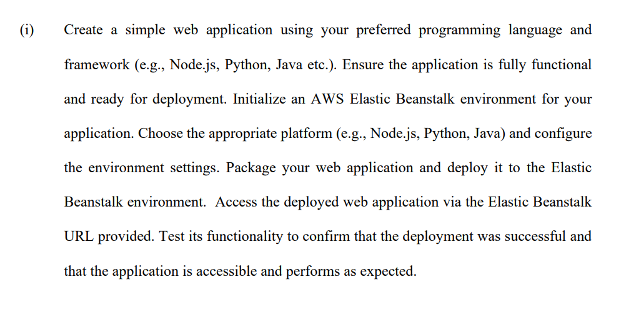

**SOLUTION: -**

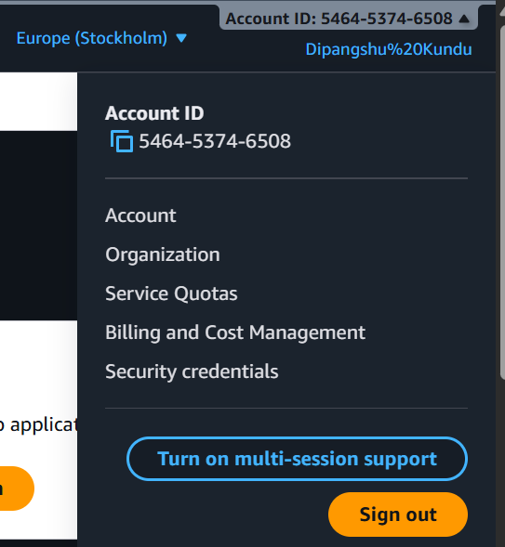

**CREATING A NEW APPLICATION**

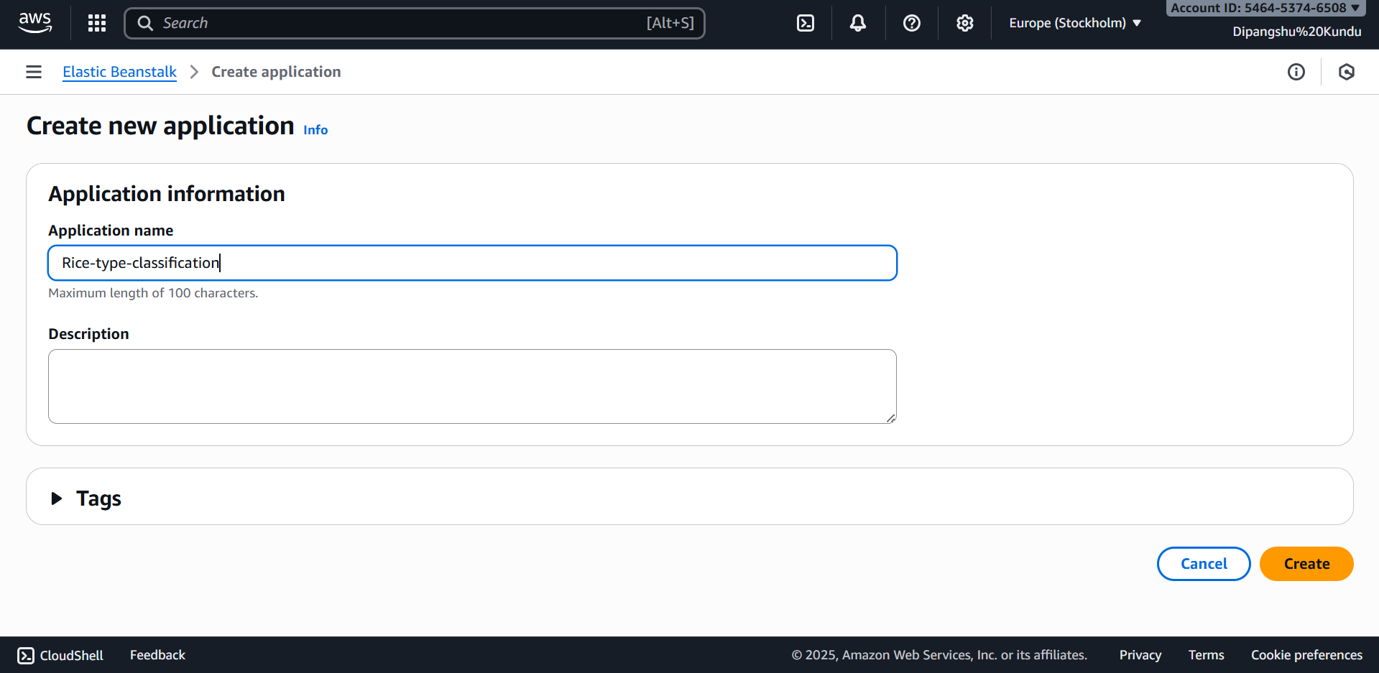

**CREATING AND CONFIGURING AN ENVIRONMENT**

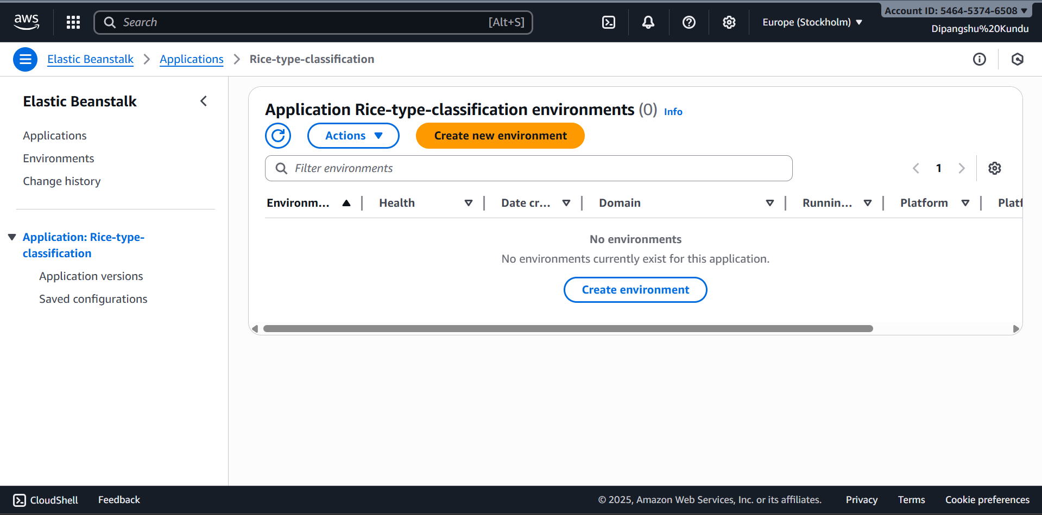

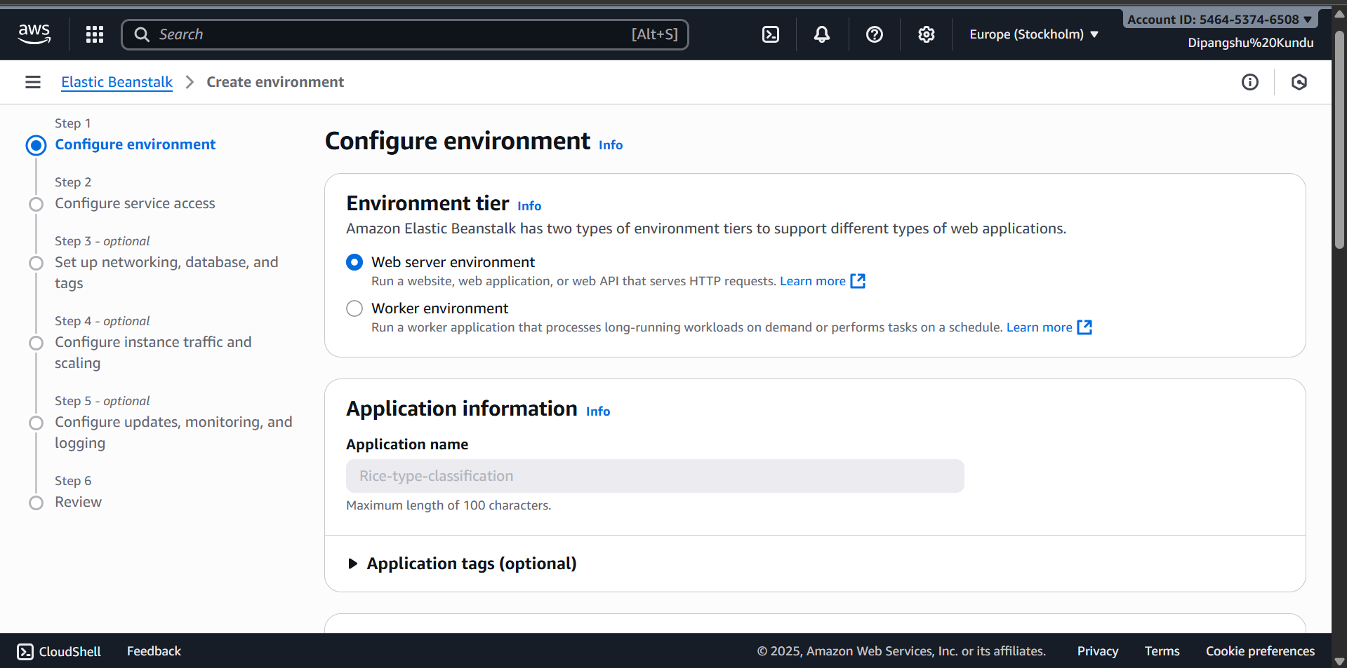

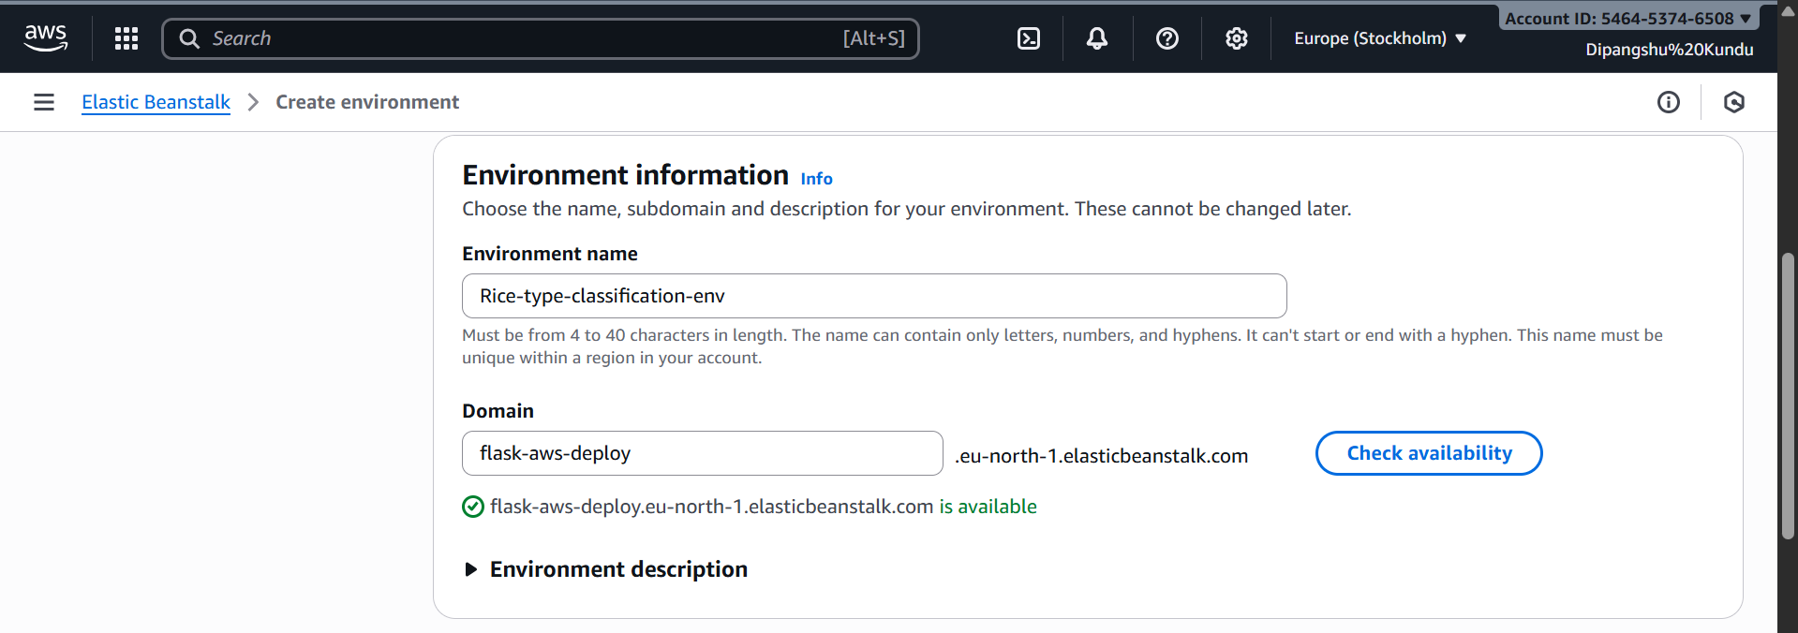

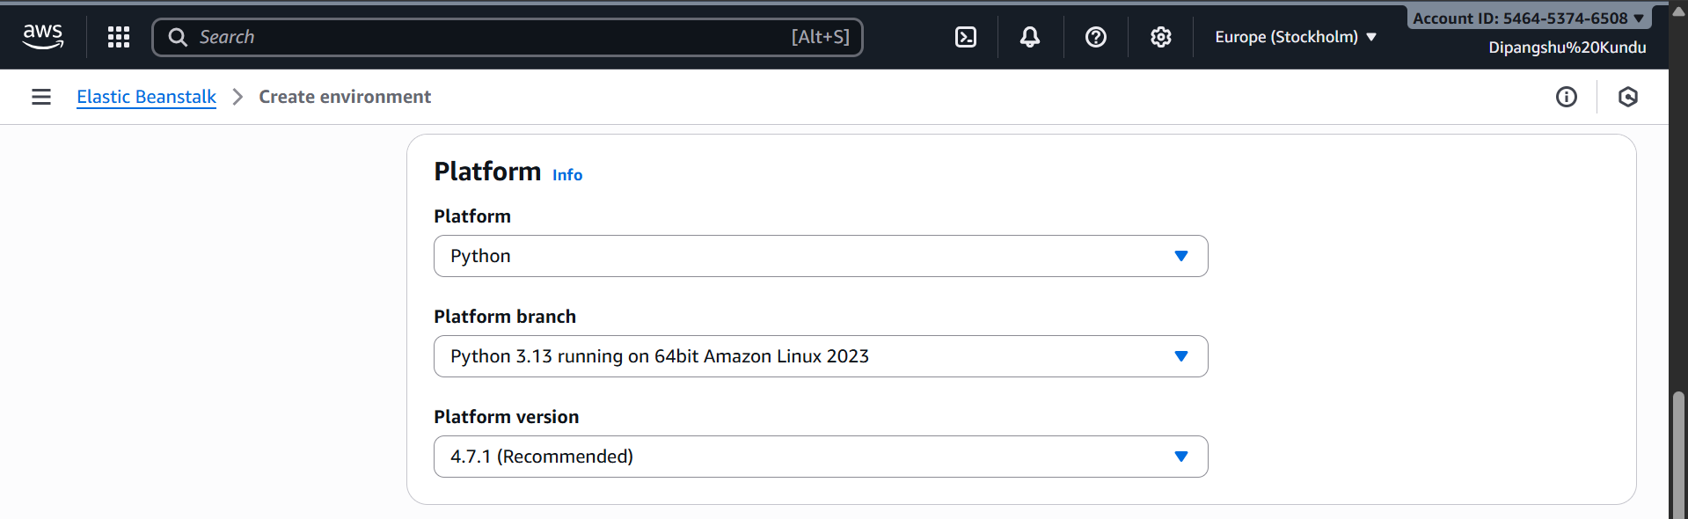

**STRUCTURE OF FOLDER AND UPLOADING THE ZIP FILE**

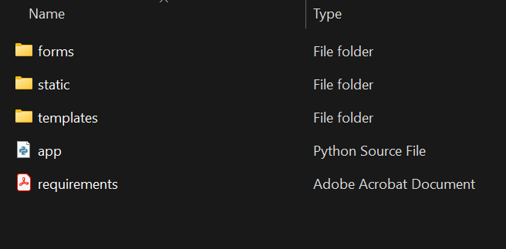

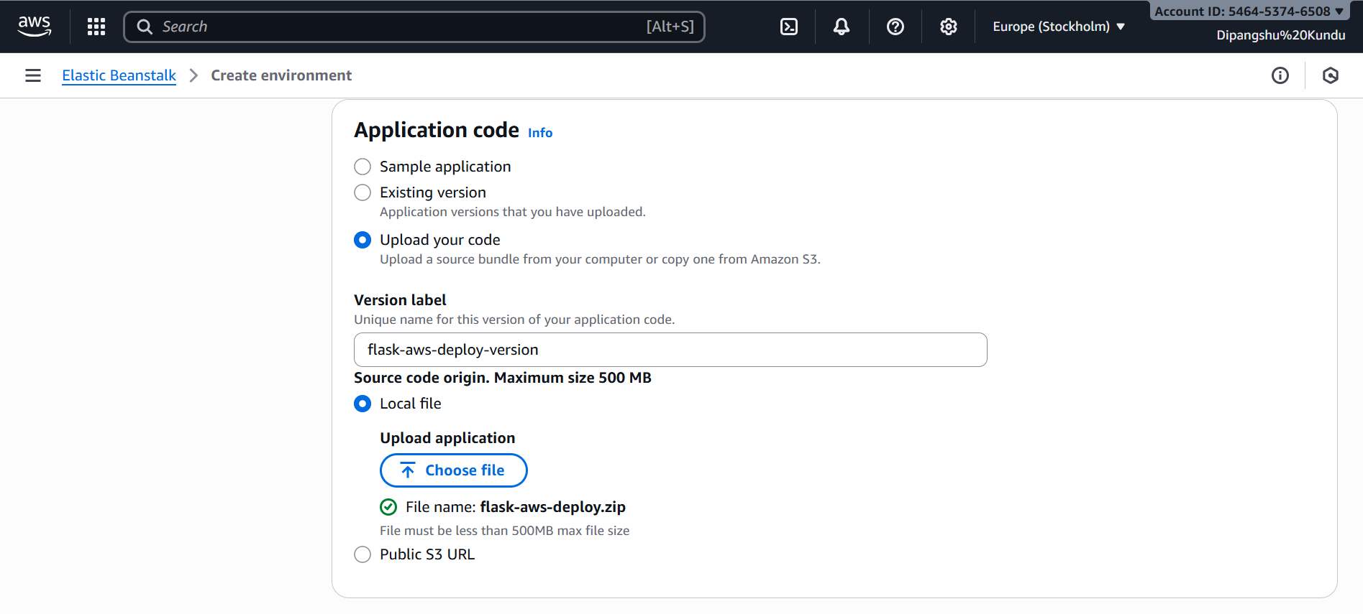

**CREATING THE SPECIFIC ROLES REQUIRED**

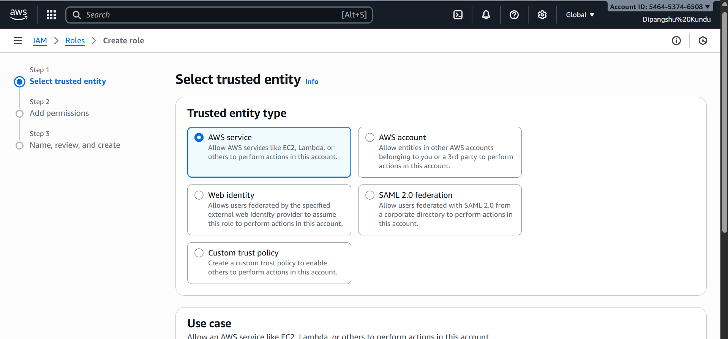

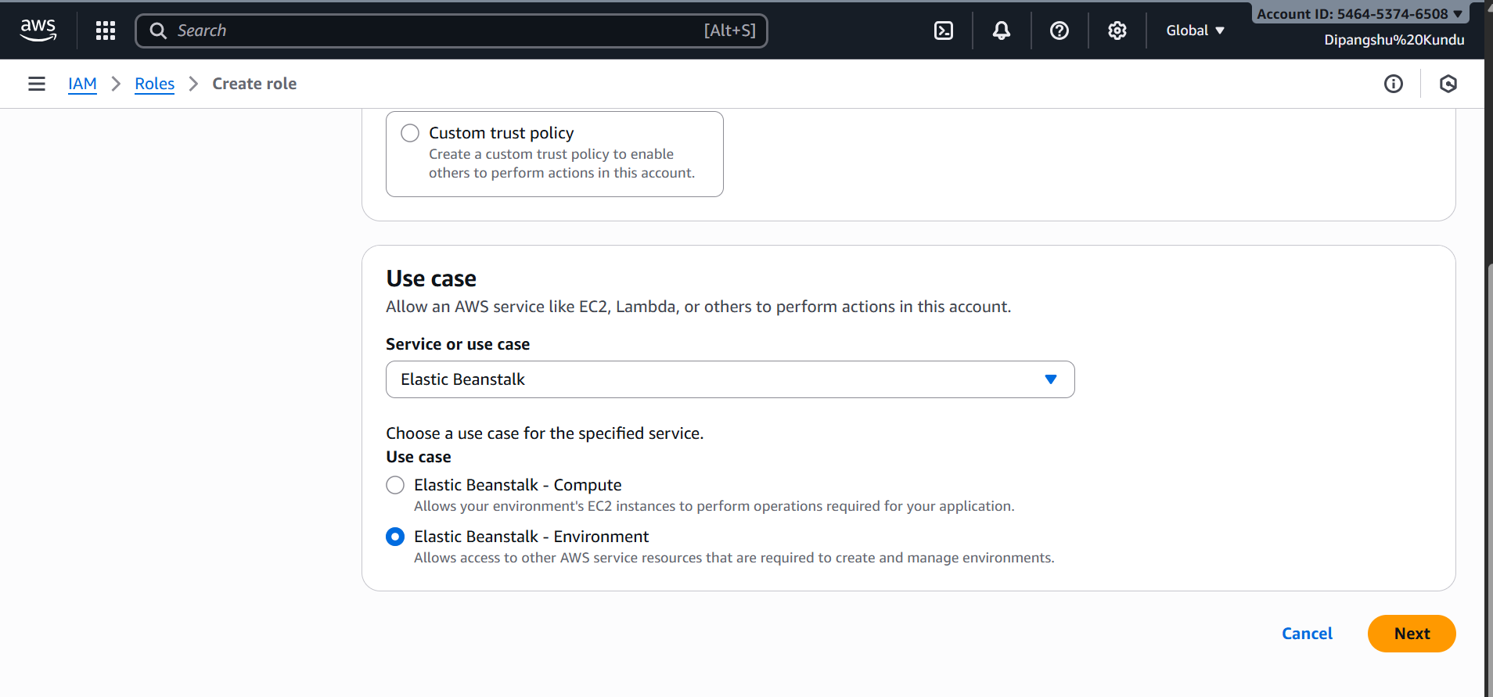

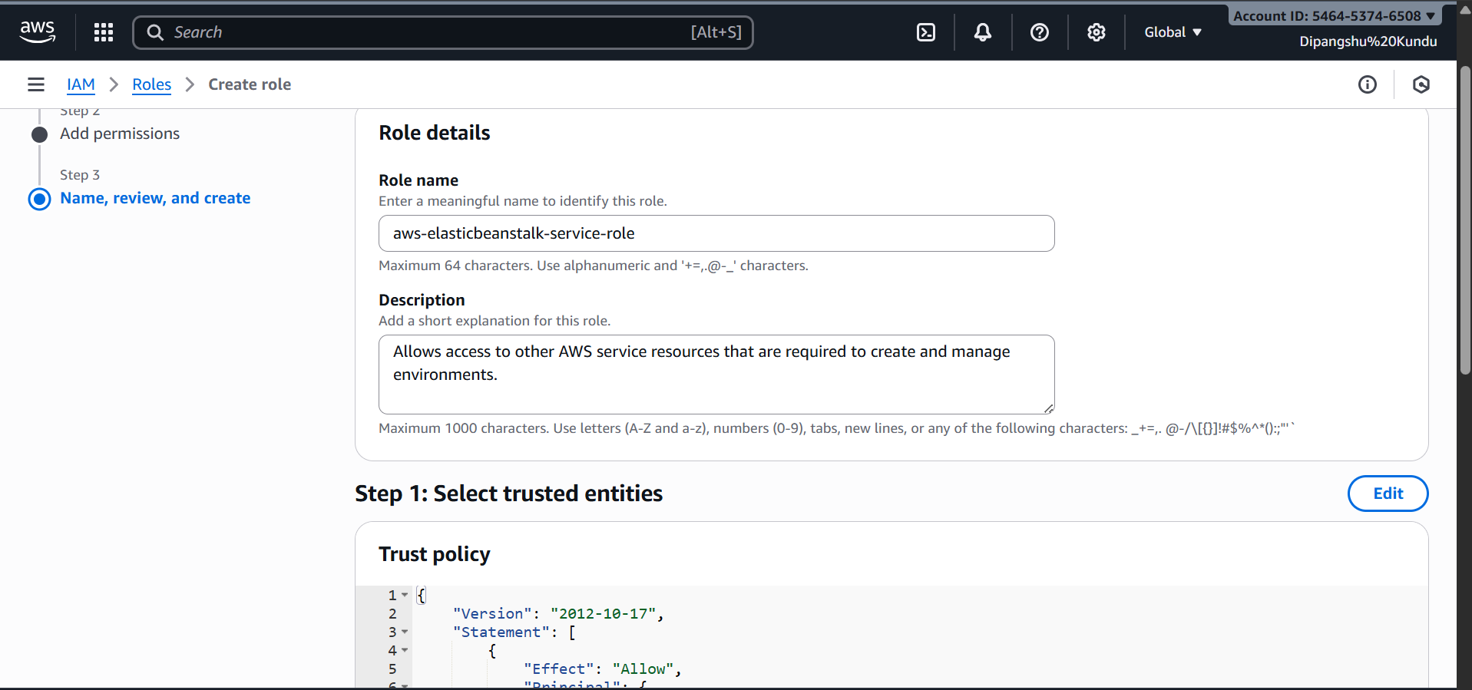

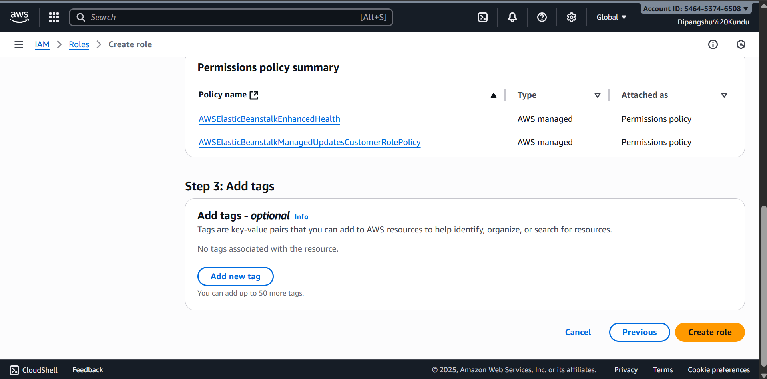

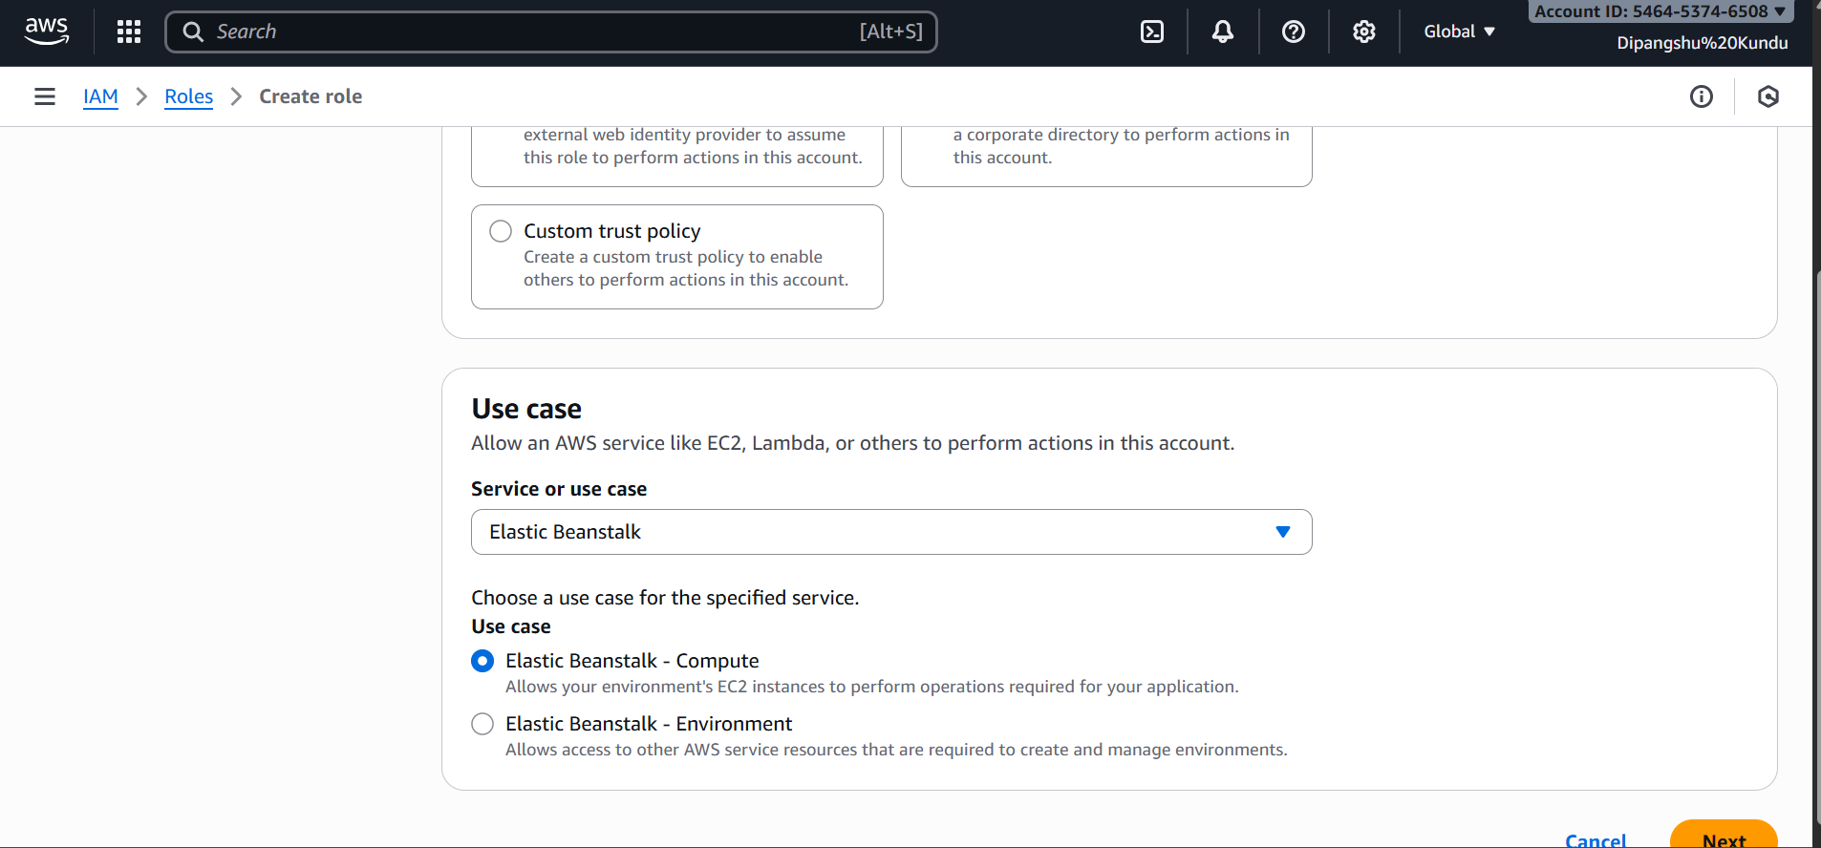

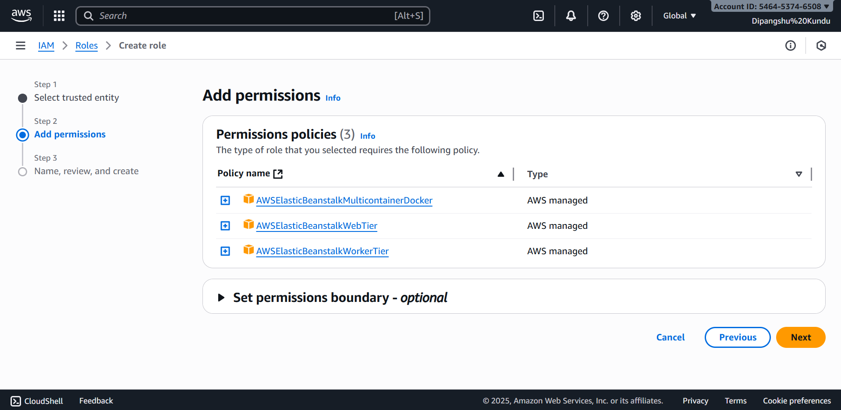

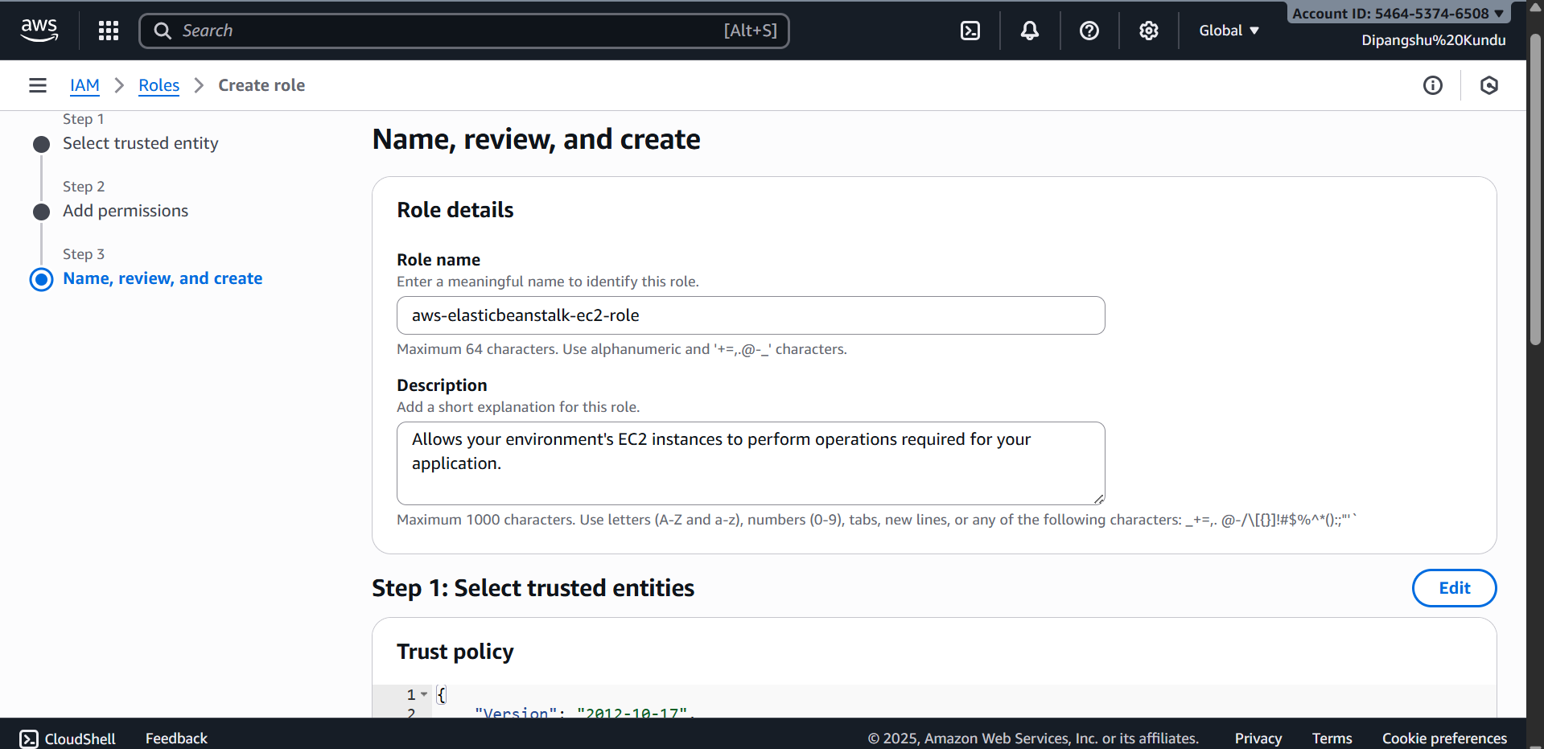

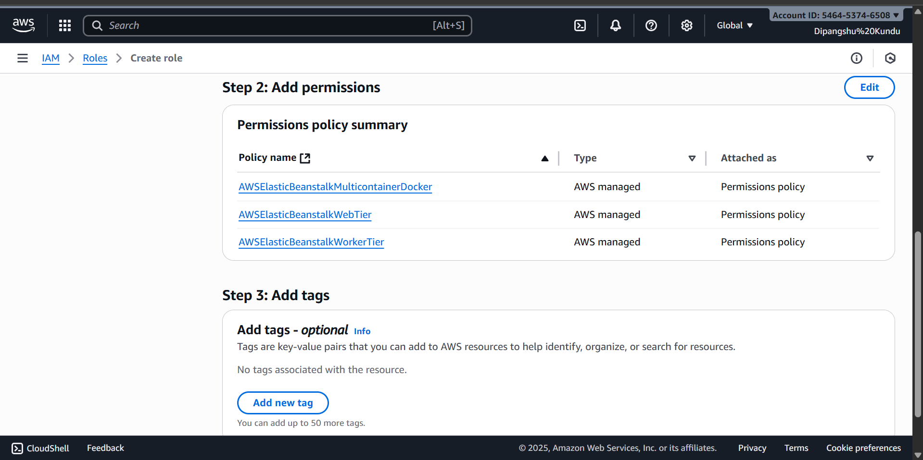

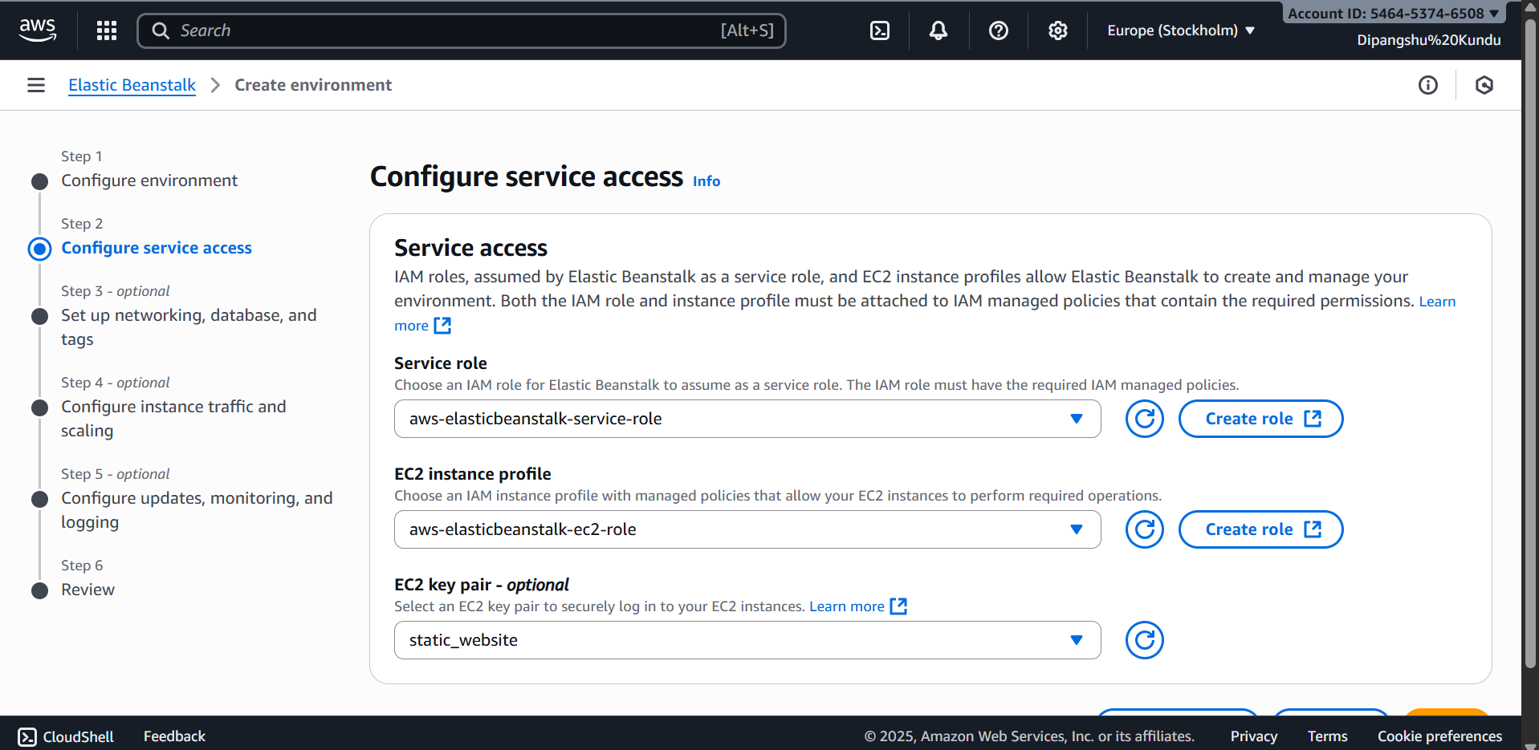

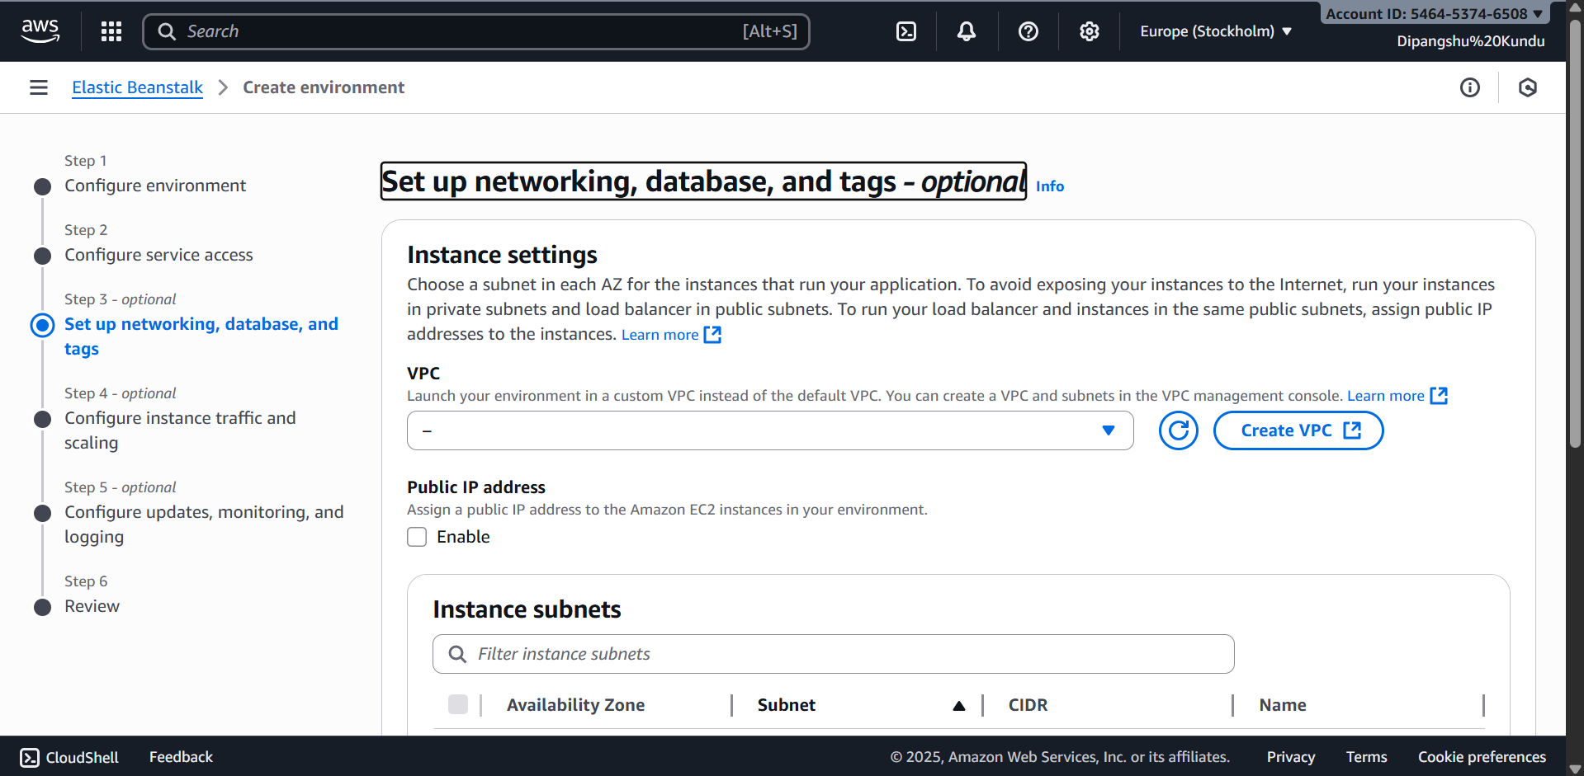

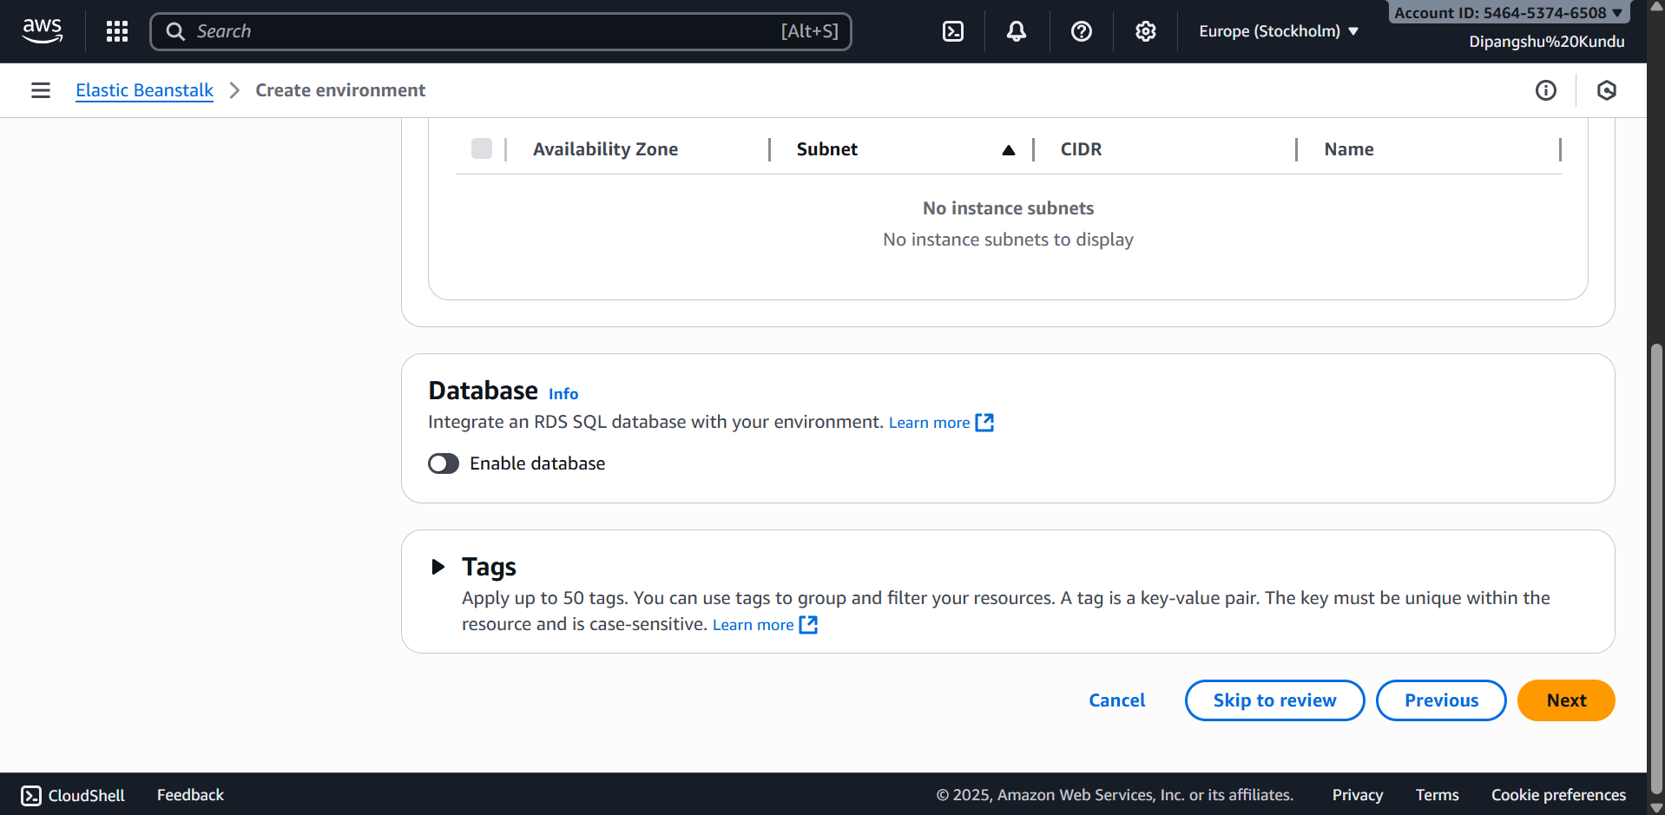

**SUBMITTING THE REVIEW**

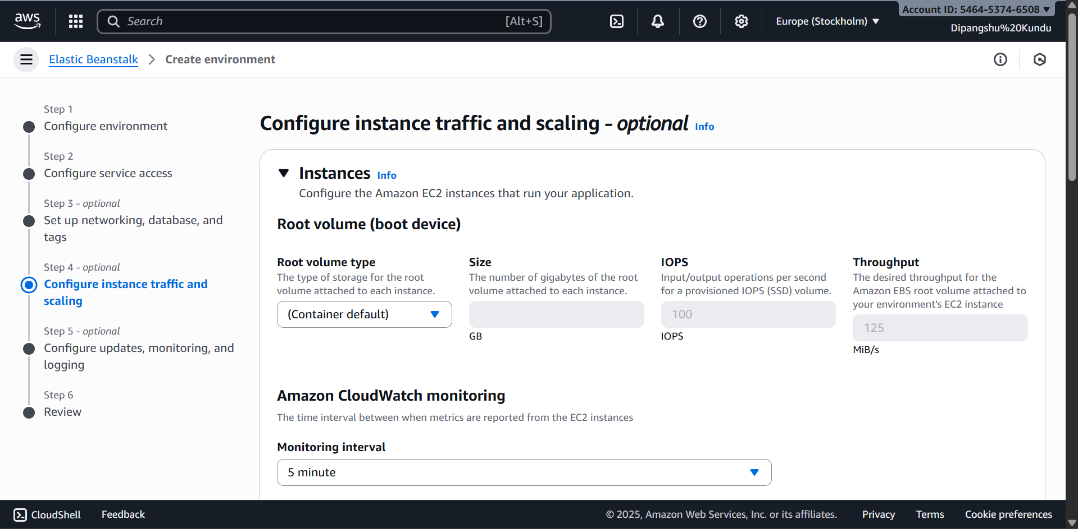

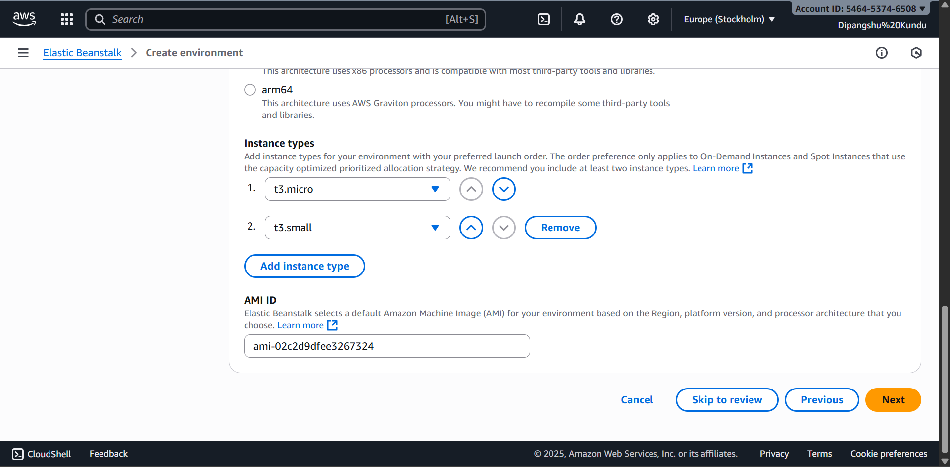

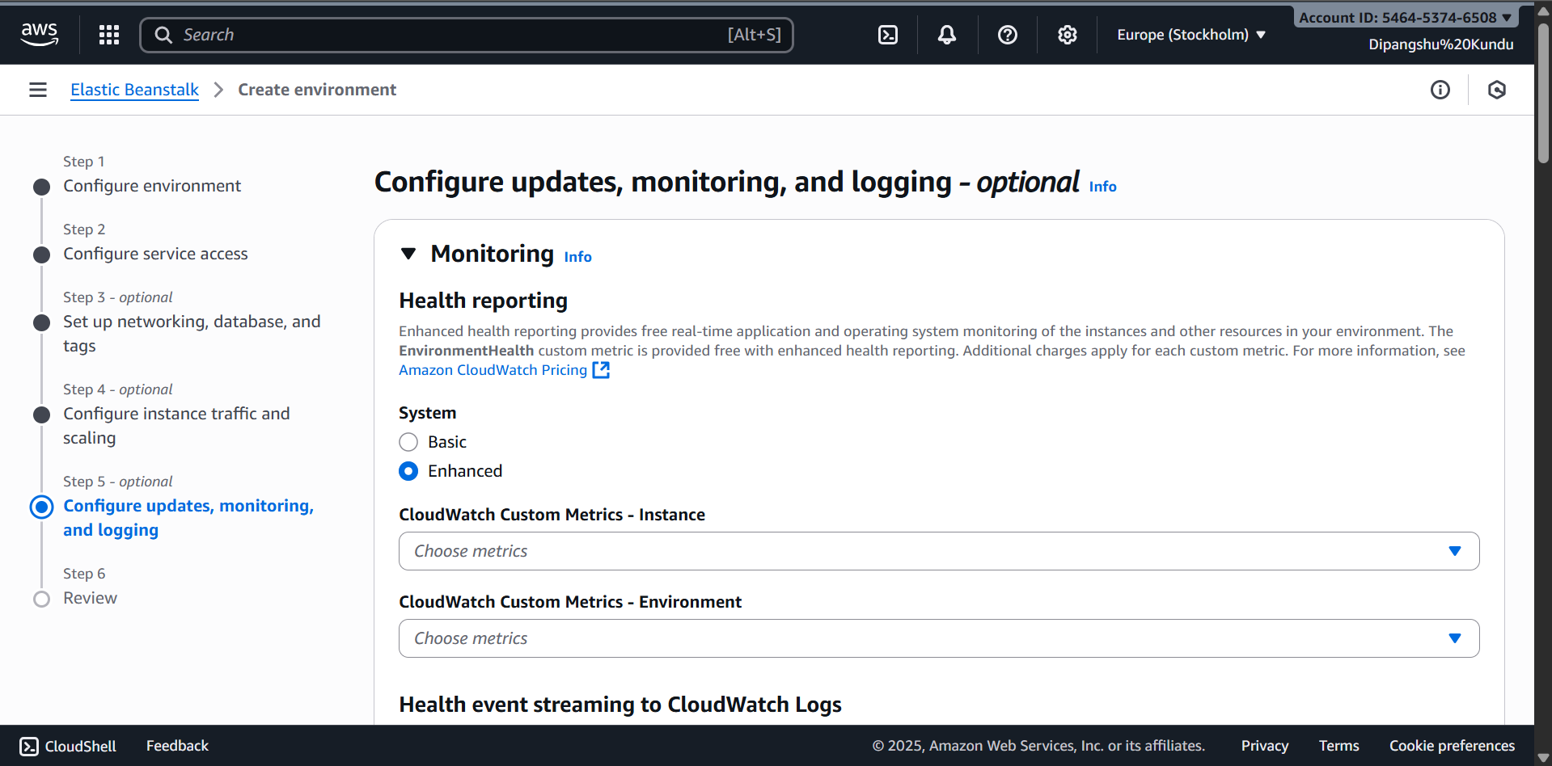

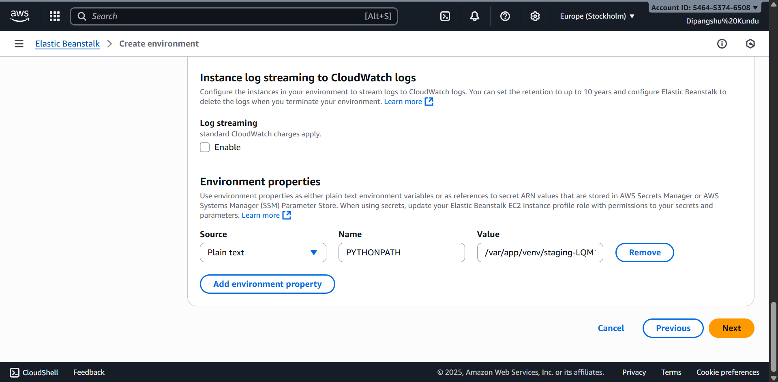

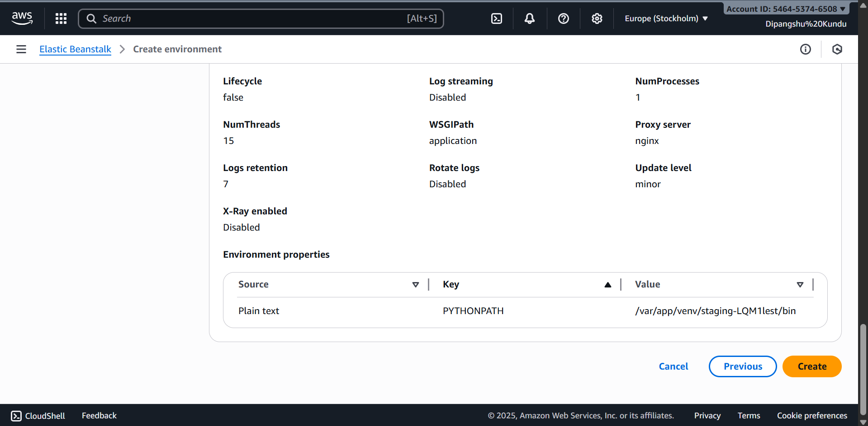

**ENVIRONMENT SUCCESSFULLY LAUNCHED**

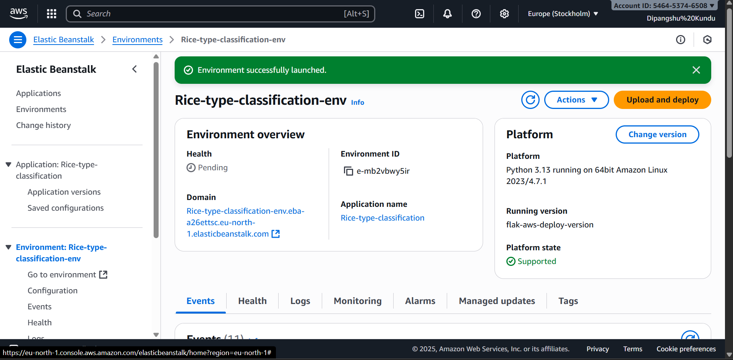

**OUTPUT SCREENSHOTS:**

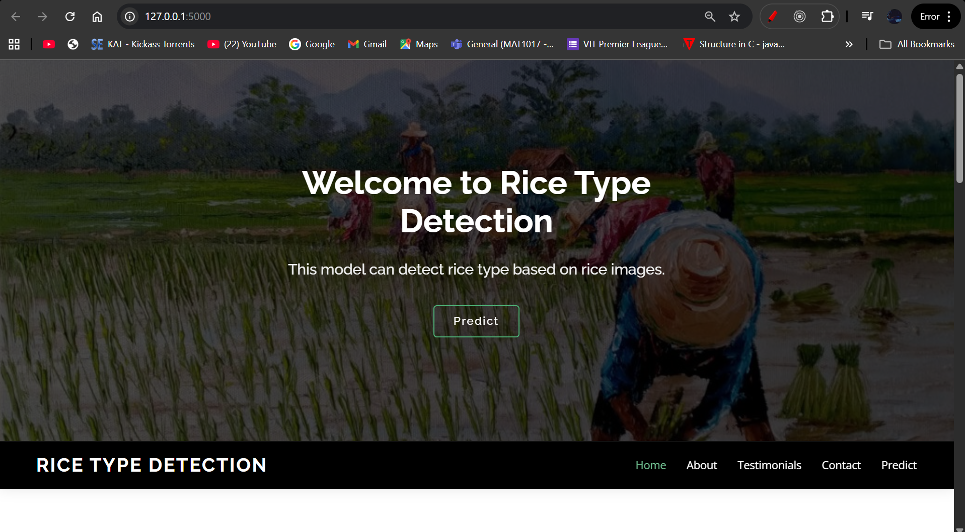

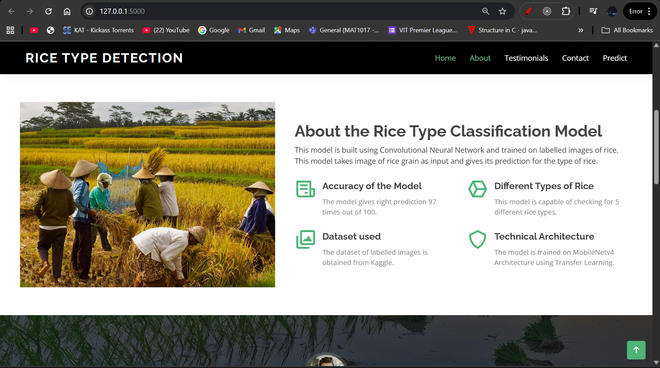

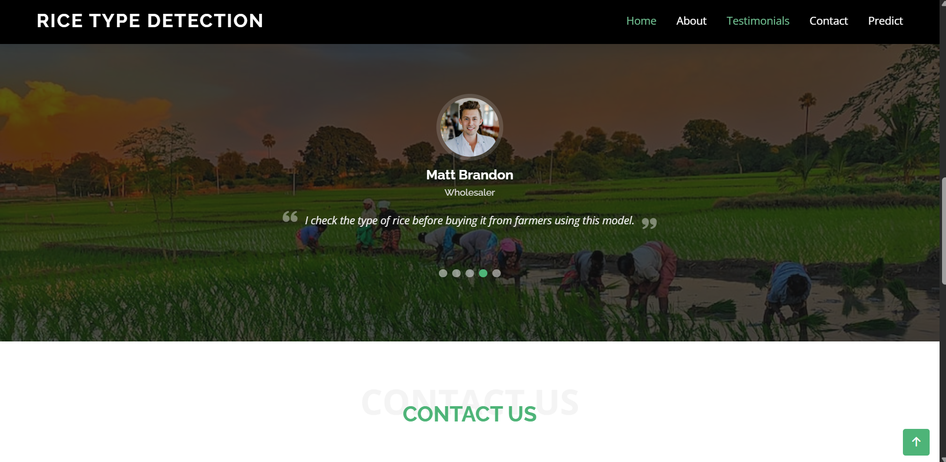

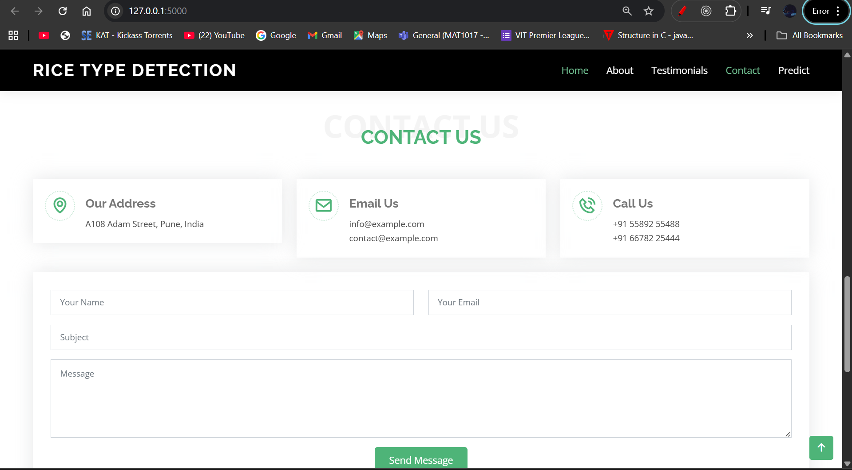

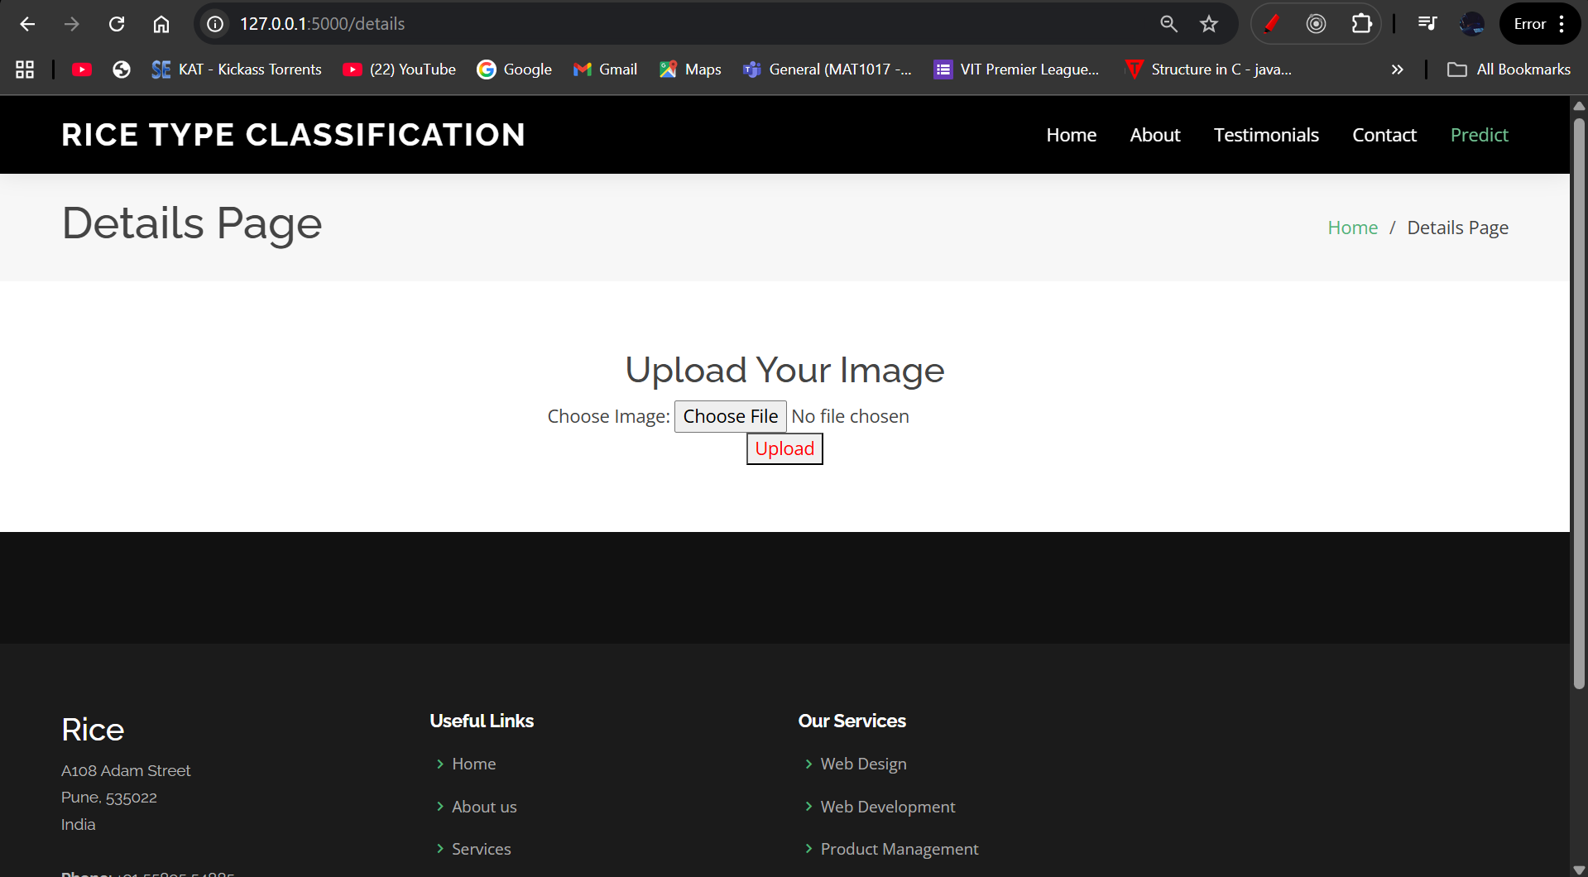

**WEBSITE LINK FROM AWS ELASTIC BEANSTALK(THIS LINK WILL NOT WORK AFTER A CERTAIN TIME DUE TO ITS FREE TIER NATURE)**

[Click_Here_To_Be_Redirected](http://flask-app-env.eba-ube8eshe.eu-north-1.elasticbeanstalk.com/)

Below is the output, on clicking the above link we will be redirected:

